**EXPERIMENT NO. 01**

|  |
| --- |
| NAME: Ayush Vinod Upadhyay  ROLL NO: I025  SAP ID: 60003220131  BRANCH: Information Technology  BATCH: 1 |

**CO/LO:** **Develop web applications.**

**AIM / OBJECTIVE:** **HTML: Design a website including basic html tags, list, image, links, table and forms using only HTML.**

**DESCRIPTION OF EXPERIMENT:**

1. Head Tag

The head tag <head> contains all the elements describing the document.

2. Title Tag

The title tag <title> specifies the HTML page title, which is shown in the browser’s title bar.

3. Body Tag

The body tag <body> is where you insert your web page’s content.

4. Paragraph Tag

A paragraph tag <p> is used to define a paragraph on a web page.

5. Heading Tag

The HTML heading tag is used to define the heading of the HTML document. The <h1> tag defines the most important tag, and defines the least.

6. Emphasis tag

The HTML tag is used to emphasize the particular text in a paragraph.

7. Bold Tag

The <b> tag is used to make the text bold.

8. Italic Tag

The <i> tag is used to make the text italic.

9. Underline Tag

The <u> tag is used to set the text underline.

10. Link Tag

The <a> tag links one page to another page. The href attribute is used to define

11. The List Item

The <li> tag is used if you want to enter the contents in the listed order. There are two types of lists.

12. Image Tag

The <img> tag is used to embed an image in an HTML document. You need to specify the source of the image inside the tag.

13. The Table Tag

The <table> tag is used to create a table in the HTML document. The table row () tag is used to make the rows in the table, and the table data () tag is used to enter the data in the table

14. Form Tag Top of Form

The <form>

tag is used to create a container which takes in input from the user by

making use of tag. By adding an action link in the form you can redirect the user or store the information using PHP

|  |
| --- |
|  |

**SOURCE CODE:**

Index.html

<!DOCTYPE html>

<html lang="en">

<head>

    <meta charset="UTF-8">

    <meta http-equiv="X-UA-Compatible" content="IE=edge">

    <meta name="viewport" content="width=device-width, initial-scale=1.0">

    <title>My First Page</title>

    <style>

        body{

            background-color: rgb(241, 158, 230);

        }

    </style>

</head>

<!-- This is a body tag -->

<body>

    <h1> Hello world </h1>

    <h2> Heading 2</h2>

    <h3> Heading 3</h3>

    <h4> Heading 4</h4>

    <h5> Heading 5</h5>

    <h6> Heading 6</h6>

    <p><b><i><u>sample Paragraph</u></i></b></p>

    <!-- It is a absolute link -->

    <a href="https://youtube.com/@ayush1344" target="_main"> My youtube </a>

    <br />

    <!-- It is a relative link -->

    <a href="/hello.html"> Hello_World</a>

    <hr>

    <a href="https://apple.com"><img src="/apple.jpg" alt="apple" height="100"/></a>

    <hr>

    <big> This is to show big Text </big>

    <br>

    <small> This is to show small Text </small>

    <hr>

    <p>H<sub>2</sub>O <br /> 3<sup>2</sup>=9 </p>

    <hr>

    <pre>a      y      u       s       h</pre>

    <hr>

    <a href="table.html"><h3>Table</h3></a>

    <hr>

    <a href="forms.html"><h3>Forms</h3></a>

    <hr>

    <iframe width="200" height="200" src="https://www.youtube.com/embed/a7NdUkV2_Gw" title="YouTube video player" frameborder="0" allow="accelerometer; autoplay; clipboard-write; encrypted-media; gyroscope; picture-in-picture; web-share" allowfullscreen></iframe>

</body>

</html>

hello.html

<!DOCTYPE html>

<html lang="en">

<head>

    <meta charset="UTF-8">

    <meta http-equiv="X-UA-Compatible" content="IE=edge">

    <meta name="viewport" content="width=device-width, initial-scale=1.0">

    <title>Document</title>

</head>

<body>

    <!-- Using semantics of header main and footer for page layout-->

    <header><H1><pre>Education     Projects</pre></H1></header>

    <main>

        <hr>

        <section>Education : DJ Sangvi | HSC | SSC</section>

        <section>Activities: VJTI technovanza Hackathon</section>

        <article>My story:</article>

        <aside>Using aside tag we can show adds</aside>

        <hr>

        <!-- <div> tag is a block element. It occupies the entire area. Initially its height is 0. -->

        <div>

            <p>Block1 - 1</p>

            <p>Block1 - 2</p>

        </div>

        <div>

            <p>Block2 - 1</p>

            <p>Block2 - 2</p>

        </div>

        <hr>

        <!-- Inline elements use very limited space -->

        <!-- Span is an inline tag -->

        <span> Yooo! </span>

        <hr>

        <!-- Following is unordered list -->

        <ul>

            <li>

                Mango

                <ul>

                    <li>Color: Yellow</li>

                    <li>Season: Summer</li>

                </ul>

            </li>

            <li>

                Apple

                <ul>

                    <li>Color: Red</li>

                    <li>Season: Winter</li>

                </ul>

            </li>

        </ul>

        <hr>

        <!-- FOllowing is ordered list -->

        <ol>

            <li>

                Mango

                <ol>

                    <li>Color: Yellow</li>

                    <li>Season: Summer</li>

                </ol>

            </li>

            <li>

                Apple

                <ol>

                    <li>Color: Red</li>

                    <li>Season: Winter</li>

                </ol>

            </li>

        </ol>

        <hr>

    </main>

    <footer>Contact me at ayush.up105@gmail.com</footer>

</body>

</html>

forms.html

<!DOCTYPE html>

<html lang="en">

<head>

    <meta charset="UTF-8">

    <meta http-equiv="X-UA-Compatible" content="IE=edge">

    <meta name="viewport" content="width=device-width, initial-scale=1.0">

    <title>Document</title>

</head>

<body>

    <main>

        <h3>Registration Form</h3>

        <form action="/action.php">

            <input type="text" placeholder="Type your name">

            <input type="password" placeholder="Enter Password">

            <hr>

            <label for="1010">

            <input type="radio" value="MHT-CET" name="Exam" id="1010">MHT-CET

            </label>

            <br>

            <label for="1020">

            <input type="radio" value="JEE" name="Exam" id="1020">JEE

            </label>

            <hr>

            <label for="101">

                <input type="checkbox" value="Math" name="Subject" id="101">Math

            </label>

            <br>

            <label for="102">

                <input type="checkbox" value="Phy" name="Subject" id="102">Phy

            </label>

            <br>

            <label for="103">

                <input type="checkbox" value="Chem" name="Subject" id="103">Chem

            </label>

            <br>

            <label for="104">

                <input type="checkbox" value="CS" name="Subject" id="104">CS

            </label>

            <hr>

            <select name="City">

                <option value="Delhi">Delhi</option>

                <option value="Mumbai">Mumbai</option>

                <option value="Pune">Pune</option>

                <option value="Banglore">Banglore</option>

            </select>

            <hr>

            <textarea name="feedback" placeholder="Give your feedback" id="001" rows="5"></textarea>

            <hr>

            <input type="submit" value="submit">

        </form>

    </main>

</body>

</html>

table.html  
<!DOCTYPE html>

<html lang="en">

<head>

    <meta charset="UTF-8">

    <meta http-equiv="X-UA-Compatible" content="IE=edge">

    <meta name="viewport" content="width=device-width, initial-scale=1.0">

    <title>Document</title>

</head>

<body>

    <main>

        <table border="1" cellpadding="5" cellspacing="5" align="center">

            <thead>

                <caption>Lan's Timetable</caption>

                <tr>

                    <th></th>

                    <th></th>

                    <th colspan="3">Morning</th>

                    <th>Lunch</th>

                    <th colspan="4">Afternoon</th>

                    <th colspan="3">evening</th>

                </tr>

                <tr>

                    <th></th>

                    <th></th>

                    <th>9-10 am</th>

                    <th>10-11 am</th>

                    <th>11-12 am</th>

                    <th>1-2 pm</th>

                    <th>2-3 pm</th>

                    <th>3-4 pm</th>

                    <th>4-5 pm</th>

                    <th>5-6 pm</th>

                    <th>6-7 pm</th>

                    <th>7-8 pm</th>

                    <th>8-9 pm</th>

                </tr>

            </thead>

            <tbody>

                <tr>

                    <th rowspan="2">Work</th>

                    <td>Monday</td>

                    <td colspan="3">Development Meeting</td>

                    <td></td>

                    <td colspan="3">Client Meeting</td>

                    <td>Commute</td>

                    <td colspan="3">Free</td>

                </tr>

                <tr>

                    <td>Tuesday</td>

                    <td colspan="3">In Office</td>

                    <td></td>

                    <td colspan="7">In Office</td>

                </tr>

                <tr>

                    <th rowspan="2">Lecture</th>

                    <td>Wednesday</td>

                    <td colspan="3">CSC205</td>

                    <td></td>

                    <td colspan="7">preperation</td>

                </tr>

                <tr>

                    <td>Thursday</td>

                    <td colspan="3">MAM200</td>

                    <td></td>

                    <td colspan="3">Tutorials for MAM200</td>

                    <td colspan="4">Free</td>

                </tr>

                <tr>

                    <th>Research</th>

                    <td>Friday</td>

                    <td colspan="3">Research</td>

                    <td></td>

                    <td colspan="7">Research</td>

                </tr>

            </tbody>

        </table>

    </main>

</body>

</html>

**OUTPUT:**

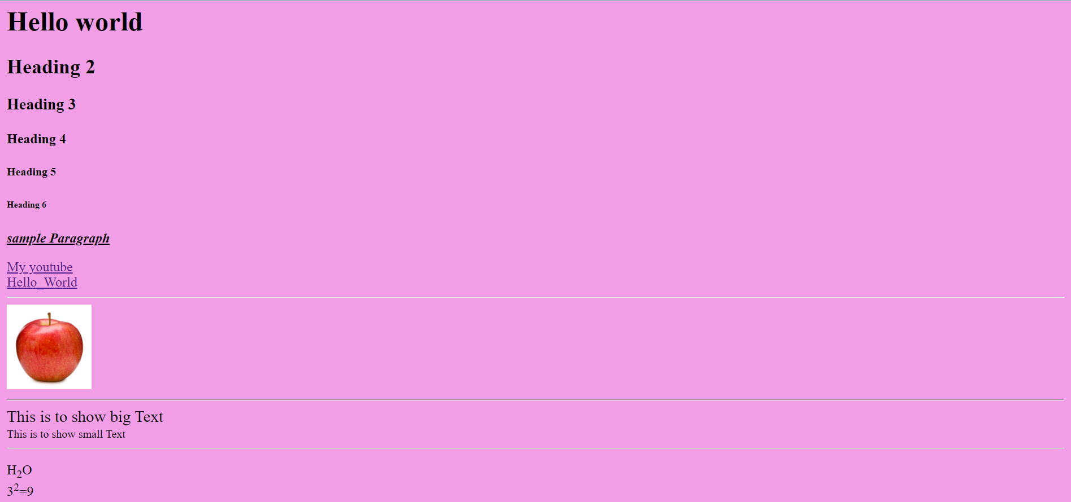

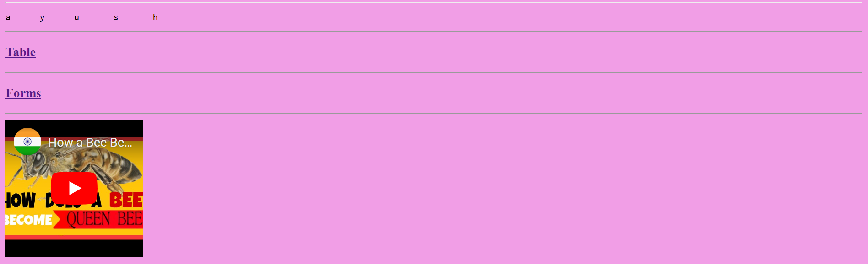

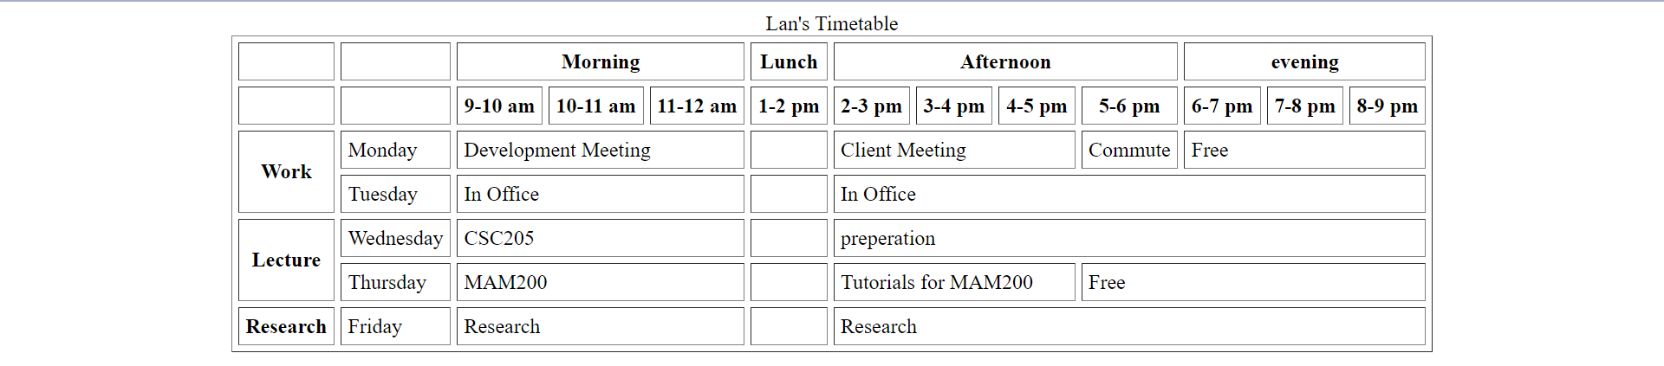

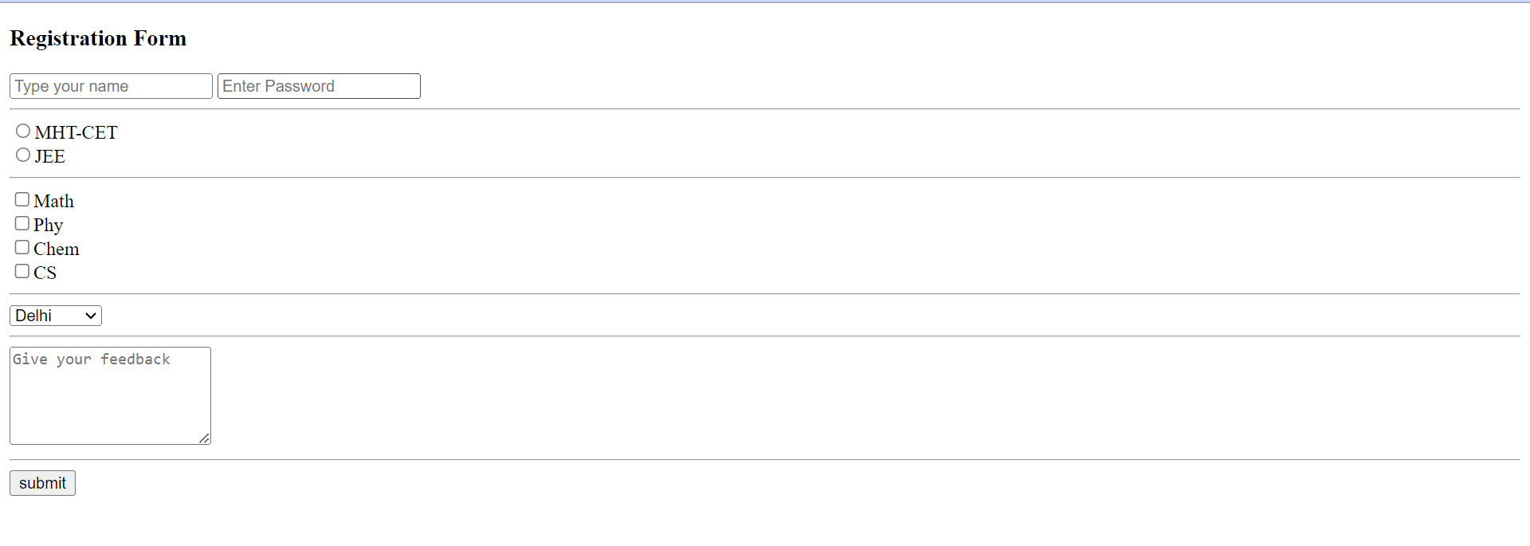

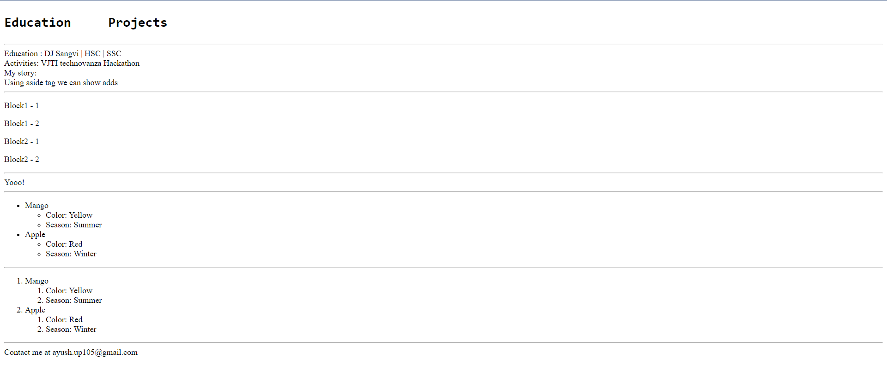

**CONCLUSION:**

I learnt about the basic html tags and their implementation. I learnt to create tables and forms with help of html.

**​Website References:​**

Apna College html basics